VISVESVARAYA TECHNOLOGICAL UNIVERSITY
“Jnana Sangama”, Belgaum -590014, Karnataka.


FULLSTACK WEB DEVELOPMENT PROJECT REPORT
On

“SKILL – IT”

Submitted by

SANATH S SHETTY (1BM23CS297)
SHASHANK SHANTHARAM NAYAK (1BM23CS313)
SRUJAN K R(1BM23CS340)
SUMANTH S SHETTY(1BM23CS348)

Under the Guidance of
Srushti C S
Assistant Professor
in partial fulfillment for the award of the degree of

BACHELOR OF ENGINEERING
in

COMPUTER SCIENCE AND ENGINEERING


B.M.S. COLLEGE OF ENGINEERING
(Autonomous Institution under VTU)
BENGALURU-560019
2024 - 2025

B. M. S. College of Engineering,
Bull Temple Road, Bangalore 560019
(Affiliated To Visvesvaraya Technological University, Belgaum)
Department of Computer Science and Engineering

CERTIFICATE

This is to certify that the project work entitled “SKILL-IT” carried out by SANATH S SHETTY (1BM23CS297), SHASHANK SHANTHARAM NAYAK (1BM23CS313), SRUJAN K R (1BM23CS340), SUMANTH S SHETTY (1BM23CS348), who are bonafide students of B. M. S. College of Engineering. It is in partial fulfillment for the award of Bachelor of Engineering in Computer Science and Engineering of the Visvesvaraya Technological University, Belgaum during the year 2024. The project report has been approved as it satisfies the academic requirements in respect of Full Stack Web Development(23CS3AEFWD) work prescribed for the said degree.

Signature of the Guide  Srushti C S  Assistant Professor  B.M.S. College Of Engineering  Bengaluru | Signature of the HOD  Dr. Kavitha Sooda  Professor and Head  Dept. of CSE  B.M.S. College Of Engineering  Bengaluru
Name of the Examiner | Signature with date

B.M.S. COLLEGE OF ENGINEERING

DEPARTMENT OF COMPUTER SCIENCE AND ENGINEERING


DECALARATION

We, SANATH S SHETTY (1BM23CS297), SHASHANK SHANTARAM NAYAK (1BM23CS313), SRUJAN K R (1BM23CS340), SUMANTH S SHETTY (1BM23CS348), students of 3rd Semester, B.E, Department of Computer Science and Engineering, BMS College of Engineering, Bangalore, hereby declare that this Full Stack Web Development project entitled "Skill-It" has been carried out by us under the guidance of Srushti C S, Assistant Professor, Department of CSE, B.M.S College of Engineering, Bangalore, during the academic semester Sept 2024 - Jan 2025.

We also declare that, to the best of our knowledge and belief, the development reported here is not a part of any other report by any other students.
Signatures
SANATH S SHETTY (1BM23CS297)

SHASHANK SHANTHARAM NAYAK (1BM23CS313)

SRUJAN K R(1BM23CS340)

SUMANTH S SHETTY(1BM23CS348)

ABSTRACT
This report details the development of Skill-It, a full-stack web application designed to connect individuals interested in sharing or obtaining skills online. The project aims to bridge the gap between skill providers and seekers, fostering collaboration, innovation, and growth. Skill-It provides a platform for users to create profiles, upload skills, and search for learning opportunities or expertise with ease.
The website's technical foundation consists of Node.js and Express.js for the backend, React.js for a responsive frontend, and MySQL for data storage. This combination ensures scalability and efficiency, accommodating a large user base.
The project highlights include:
- Comprehensive user profiles showcasing skills, experience, and projects.
- Search functions allowing clients to find suitable candidates based on specific skill requirements.
- A smooth and intuitive user interface enhancing user experience.
- Robust backend ensuring scalability and efficient data handling.
Skill-It exemplifies how technology can bring people together, enabling users to build strong professional relationships and take pride in their skills. This platform aspires to inspire others and demonstrates the transformative power of technology in creating opportunities.

TABLE OF CONTENTS

Serial  No. | TITLE | PAGE  NO.
1 | Introduction | 1
1.1 | Overview | 2
1.2 | Motivation | 2
2 | Software Requirement Specification | 4
2.1 | Hardware Requirements | 4
2.2 | Software Requirements | 4
3 | ER diagram of the project | 5
4 | Schema of project | 6
5 | User Interface Design | 7-10
6 | References | 11

Chapter 1

INTRODUCTION

1.1 Overview
Skill-It is a full-stack web application designed to connect individuals interested in sharing or obtaining specific skills online. The platform seeks to bridge the gap between those wanting to learn new skills and those offering their expertise. It fosters collaboration, innovation, and personal growth by providing features such as user profiles, skill uploads, and search functions, making it easier for users to discover learning opportunities. Skill-It is built with a combination of modern technologies to ensure an efficient and scalable platform that grows with its user base.
The backend of Skill-It is powered by Node.js and Express.js, two popular technologies within the JavaScript ecosystem. Node.js, an open-source runtime environment that runs on Chrome's V8 JavaScript engine, allows for non-blocking, event-driven I/O, making it ideal for applications that need to handle numerous simultaneous connections. This asynchronous feature ensures that Skill-It can efficiently process multiple user requests without lag. Express.js, a web application framework for Node.js, simplifies the development of server-side logic. It handles routing, middleware, and other essential backend functionalities, making it easy to structure the application and ensure smooth communication between the client and server. Node.js was created by Ryan Dahl in 2009, and Express.js, first released in 2010, was developed by TJ Holowaychuk. Both have grown to be integral parts of modern web development due to their simplicity and scalability.
On the frontend, React.js was used to build a dynamic and responsive user interface. React, a JavaScript library developed by Facebook in 2013, allows developers to create reusable UI components and efficiently manage the state of these components. Its use of a virtual DOM ensures that only the necessary parts of the interface are updated when changes occur, leading to faster and more efficient rendering. React’s component-based architecture also promotes modular development, which makes the codebase easier to manage, extend, and maintain. The flexibility and performance of React make it an excellent choice for building a seamless and high-quality user experience, especially in a platform like Skill-It, where smooth user interactions are critical.
For data storage, MySQL was selected as the relational database management system (RDBMS) to handle user data, skills, and other essential information. MySQL, an open-source database created by Michael "Monty" Widenius in 1995, uses Structured Query Language (SQL) to manage and manipulate data in a tabular format. MySQL is known for its reliability, speed, and ease of use, making it a popular choice for web applications. The database provides strong data integrity and security features, which are crucial for ensuring the accuracy and privacy of the users' personal data. With MySQL, Skill-It benefits from robust transaction management, scalability, and efficient querying, which are essential for handling large volumes of data as the platform grows.
By leveraging Node.js, Express.js, React.js, and MySQL, Skill-It is able to provide a scalable, efficient, and user-friendly platform that can evolve to meet the demands of users seeking to share and acquire new skills. These technologies were chosen to ensure a seamless integration of the frontend and backend, facilitating the delivery of a high-performance, secure, and intuitive user experience.

1.2 Motivation
The Skill-It Website project represents a practical application of full-stack web development principles, aimed at creating an online platform that connects service clients seeking specific expertise with service providers offering their skills. The primary objective of this project is to develop a website that facilitates the recruitment of individuals based on the client's specific requirements, leveraging the skills and expertise of the users. Our platform is designed to bridge the gap between skilled individuals and clients in need of their expertise.
Users on Skill-It can create detailed profiles showcasing their skills, experience, and completed projects. This allows clients to search for specific skills, browse through profiles, and contact potential candidates for interviews. The platform includes features such as user profiles, skill uploads, and advanced search functions, making it easier for users to discover new skills or offer their expertise to those in need.
Moreover, the project provides an opportunity to explore innovative design and development approaches, contributing to the advancement of web development skills within the team. The idea for this project emerged from the growing competition in the tech industry, which highlighted the need for a platform where talented individuals can connect with businesses seeking their specific skills. Skill-It aims to be a space where people can showcase their abilities, gain visibility, and discover exciting new opportunities without unnecessary barriers.
Through this project, we hope to inspire others to take pride in their skills and build strong professional relationships. We believe that Skill-It will serve as a valuable resource for individuals seeking to share their expertise and for those looking to learn and grow. Our vision is to demonstrate the power of technology in connecting people and creating opportunities for collaboration, innovation, and growth.

Chapter 2

SOFTWARE REQUIREMENTS

2.1 Hardware Requirements Specification

CPU: Quad-Core processor (Intel Core i5 or AMD Ryzen 5 equivalent)

RAM: 16 GB DDR4 RAM

Storage: 512 GB SSD (Solid-State Drive)

Graphics: Integrated graphics (Intel Iris or AMD Radeon equivalent)

Display: 22-inch Full HD (1080p) monitor

Operating System: 64-bit version of Windows 10 or Linux (Ubuntu or equivalent) with kernel 6.11.x above

Internet Connection: High-speed internet connection (at least 100 Mbps)

2.2 Software Requirements Specification

OS: Windows/Linux ^{[1]}

Front-End: React JS Framework, HTML, CSS ^{[3]}

Backend: Node.js framework, Google OAuth API ^{[5]}

Server: Node.js framework

IDE: Visual Studio Code, Vim terminal editor

Chapter 3
ER – DIAGRAM

skillName
googleId

name
id
Skills
M
Users
Proficiency Level
Rate
createdAt
createdAt

N
email
HAS

profilePhoto
id
Chapter 4
SCHEMA

Users

id | googleId | email | profilePhoto | createdAt

Skills

id | skillName

Has

uid | sid | proficiencyLevel | createdAt | rate

Chapter 5
USER INTERFACE DESIGN


Fig 5.1: Home page

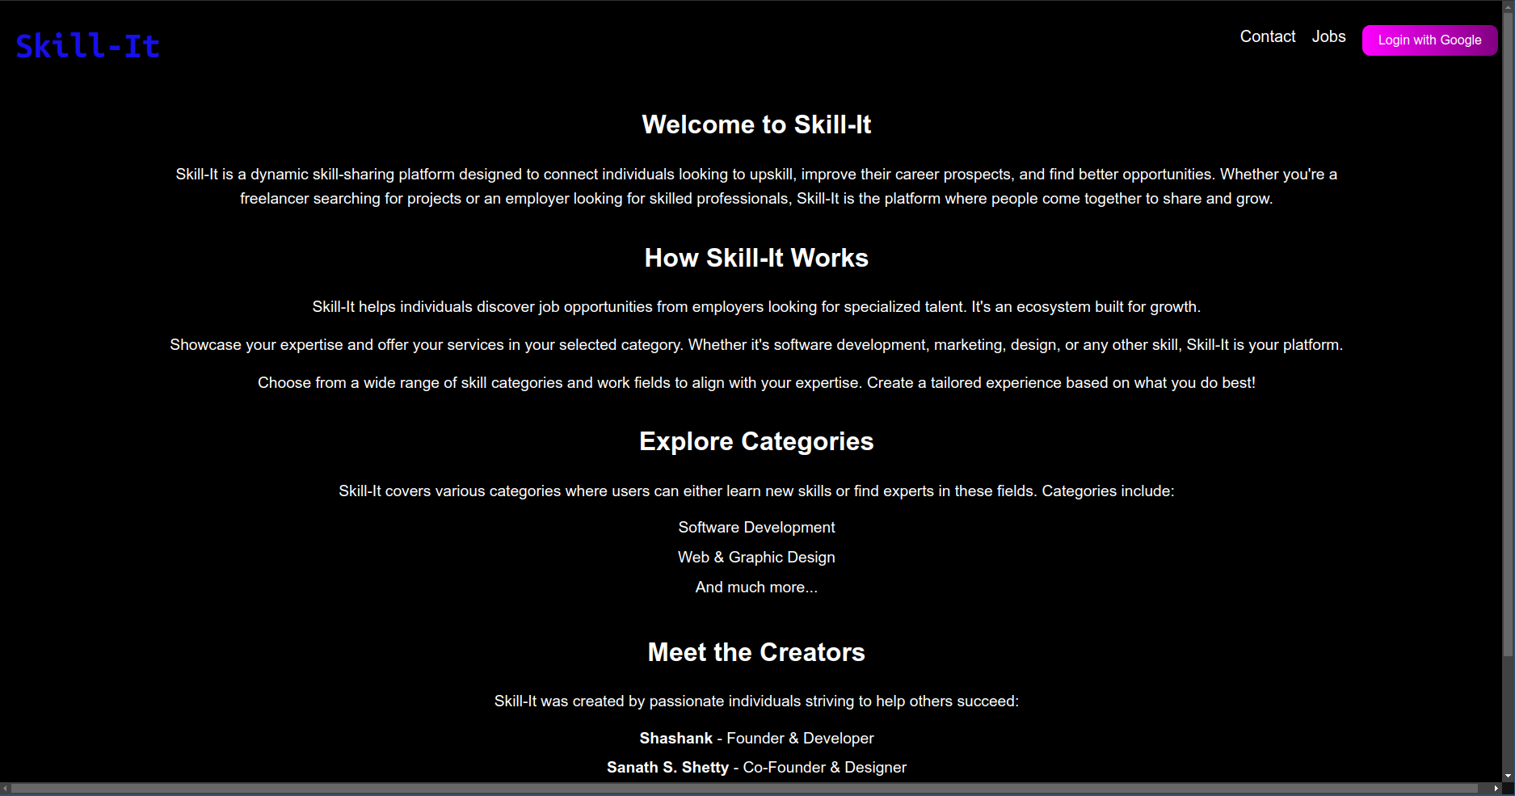
Fig 5.2: About us

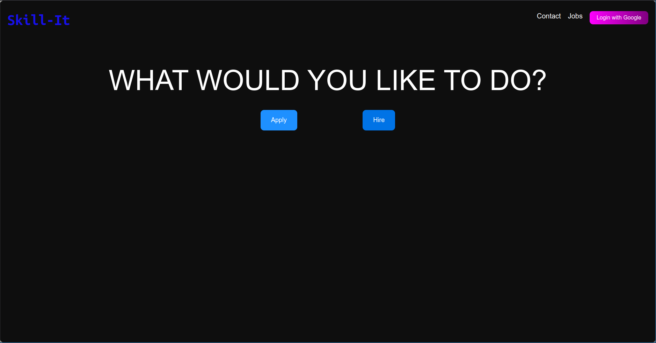
Fig 5.3: Apply or Hire

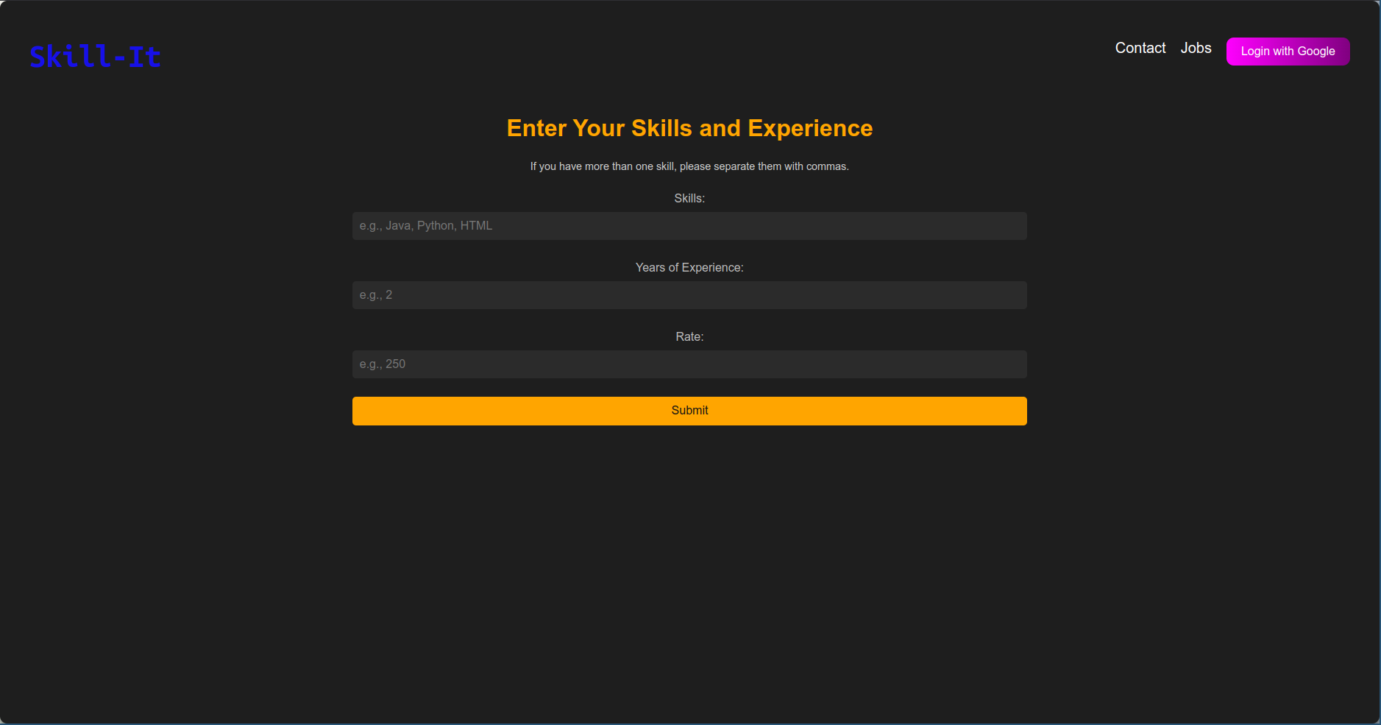
Fig 5.4: Enter your skills and experience

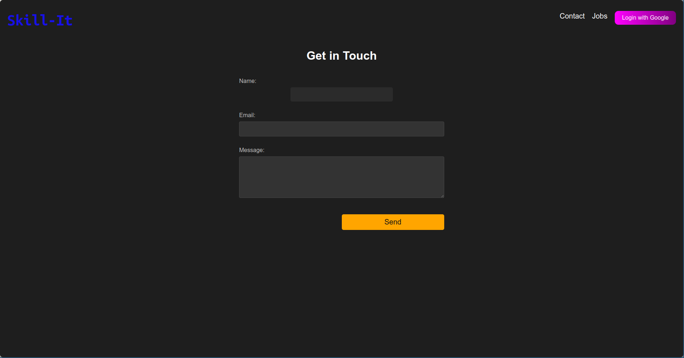

Fig 5.5: Get in touch ( contact us)

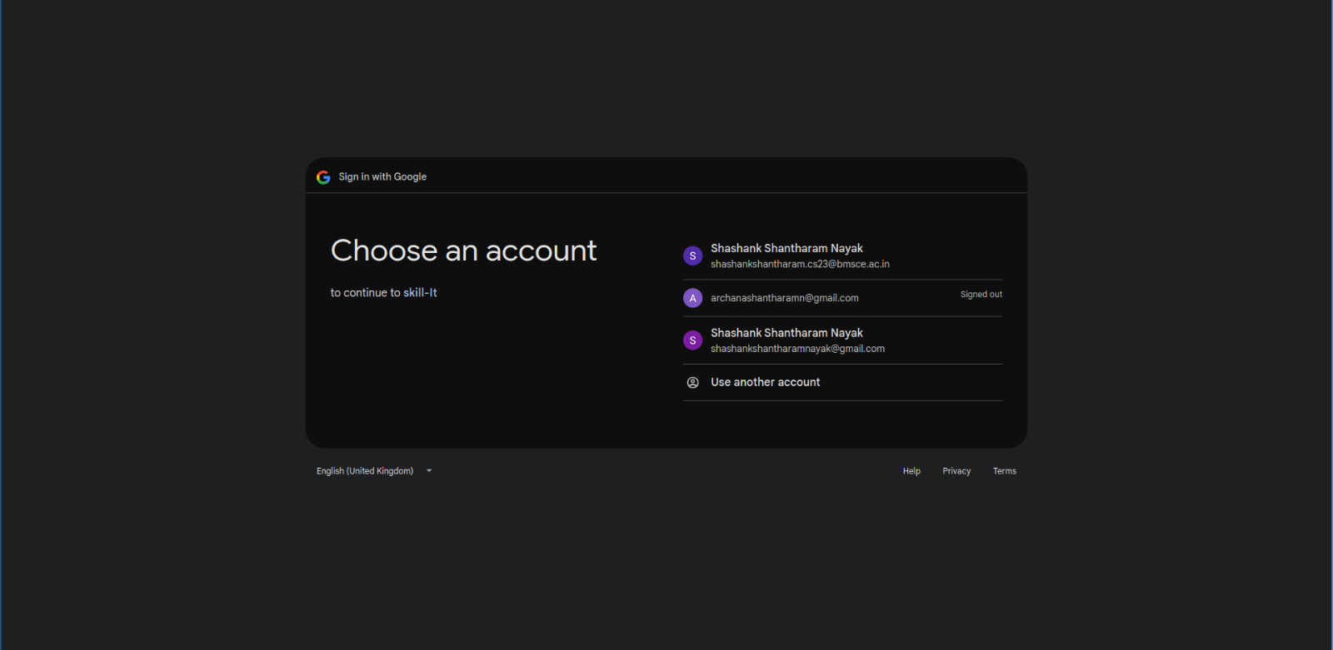

Fig 5.6: Google OAuth

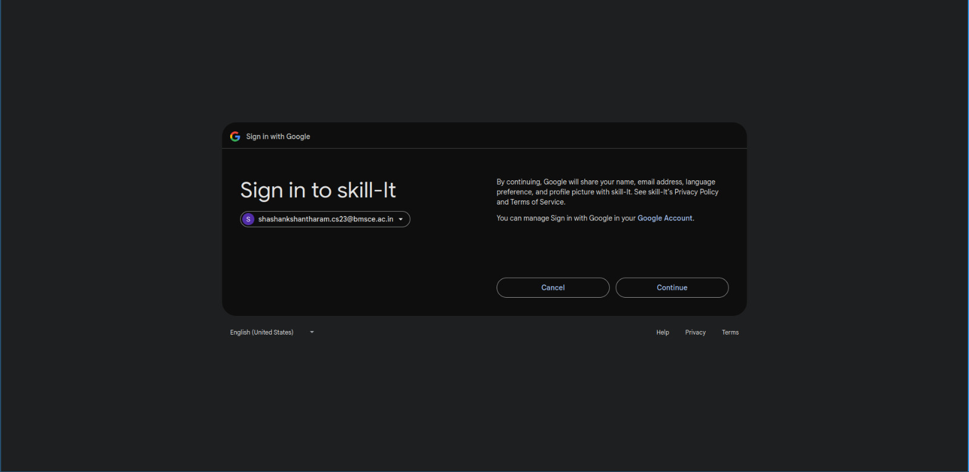

Fig 5.7: Google sign in

References

[1] https://youtu.be/CgkZ7MvWUAA?si=3Bs6X4tvlQrYHcqO

[2] https://youtu.be/PkZNo7MFNFg?si=lXFWslU4yAgz7OrY

[3] Banks, A. Learning React: A Hands-On Guide to Building Web Applications Using React, O'Reilly
Media, 2017.

[4] Oracle Corporation. ‘MySQL Documentation’. Retrieved from https://dev.mysql.com/doc/.

[5] Node.js Foundation. Node.js Documentation, Retrieved from https://nodejs.org/en/docs/

